
CENTRAL EXAMINATION SYSTEM
Project Synopsis submitted in fulfilment of the requirements for the Degree of BACHELOR OF COMPUTER APPLICATION
ANKITA MANGLA | 75178401 | BCA CTIS 4TH SEMESTER

Introduction:
Central examination system manages examination work and conduct that has to be executed before the start of the examination process. With the use of central management system; examination management related arrangements like time-table, hall tickets, allotments and results can be organized efficiently.
The central examination system is a platform through which we can conduct the exam nationally through a central database.
The main purpose of central examination system is to provide one stop solution for managing all central examination related information.

By using this, we eliminate the use of paper that promotes the “save trees” motto.

Why we need this system:
In paper-pen examination system, although the process is organised in well-defined examination branches, the movement of paper-based records is slow. The examination process in the system continues for months, causing physical and mental strain for the examinees. In addition, students are required to correspond by post or visit the headquarters in person for examination-related queries. The conventional paper-pen examination system leads to errors, greater time consumption, inefficiency and waste of valuable resources. Moreover, the ever-increasing paper-based record registers are difficult to store securely because of space scarcity. There is repetition of work because the same data is recorded in different branches. This leads to data duplication, and huge money is spent by the university to buy paper. Tampering with students’ records is possible. At times, fake degrees are prepared and no online verification is done. This leads to unfair practices and mars the credibility of the university.
In conventional system, everything is usually done by hand on paper like registration, confirmation of registration, exam information, exam writing, result declaration etc. Most of this tasks / information was done or conveyed using post mails.
The traditional examination system is long, time consuming, conducting and evaluation process. In case of paper-based exam the verification of answer and result processing are time consuming and prone to error.
The use of multimedia (like audios, videos etc.) is very difficult or we can say almost impossible to incorporate in traditional system.

Solution:
Automation has been aimed at minimizing human intervention since information and communication technology promises compact storage and speedy data retrieval. The technology can be used right from student administration to resource administration in an educational institution, where administrative subsystems include personnel, student, resources, financial and general administration. The concept of integration of the examination system will bring in scalable, transparent and vigorous e-governance solutions as the examination system can be put under a single portal system. Using online examination system, we can eliminate traditional examination system pitfall.
By integrating and storing student data from different branches of examination in a central server on a company’s networking system, the data can be made available anywhere, anytime and inconsistencies minimized.
Among the benefits are a streamlined system and procedure for collection of examination fees, issue of receipts and keeping track of the cash flow. There will be a centralised, secure and robust database of the candidates without duplication of records.
The automated process will bring improvement in the quality of services to the stakeholders by introducing a computerised window system and online availability of information.
The complete computerisation of the examination system will lead to the effective monitoring of the examination processes, minimising the possibility of fraud. The computerised statistical analysis of data will enable the authorities to observe trends in results, and the timely availability of compiled reports can be used to make strategic decisions in favour of the company and students.
In online examination system, All the exam related information can be shown on the authority’s website. students can apply / register for the exam through the website. it is secure as all the work will be dealt separately through individual login ids.
Only the person with correct login id and password will be able to access the information.
The need for middleman (like post man, courier companies) is eliminated. the system offers an optimal, time saving, secure, clean, efficient and one place solution for all information related problem.

Software Model:
Prototyping is defined as the process of developing a working replication of a product or system that has to be engineered. It offers a small-scale facsimile of the end product and is used for obtaining customer feedback as described below:
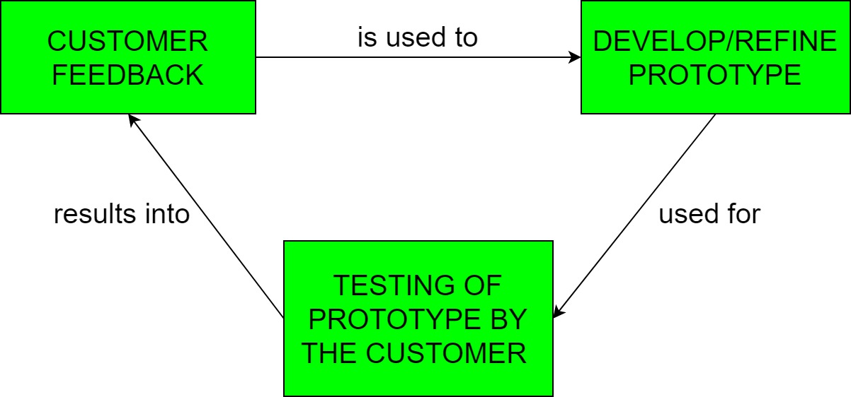
The Prototyping Model is one of the most popularly used Software Development Life Cycle Models (SDLC models). This model is used when the customers do not know the exact project requirements beforehand. In this model, a prototype of the end product is first developed, tested and refined as per customer feedback repeatedly till a final acceptable prototype is achieved which forms the basis for developing the final product.
In this process model, the system is partially implemented before or during the analysis phase thereby giving the customers an opportunity to see the product early in the life cycle. The process starts by interviewing the customers and developing the incomplete high-level paper model. This document is used to build the initial prototype supporting only the basic functionality as desired by the customer. Once the customer figures out the problems, the prototype is further refined to eliminate them. The process continues till the user approves the prototype and finds the working model to be satisfactory.

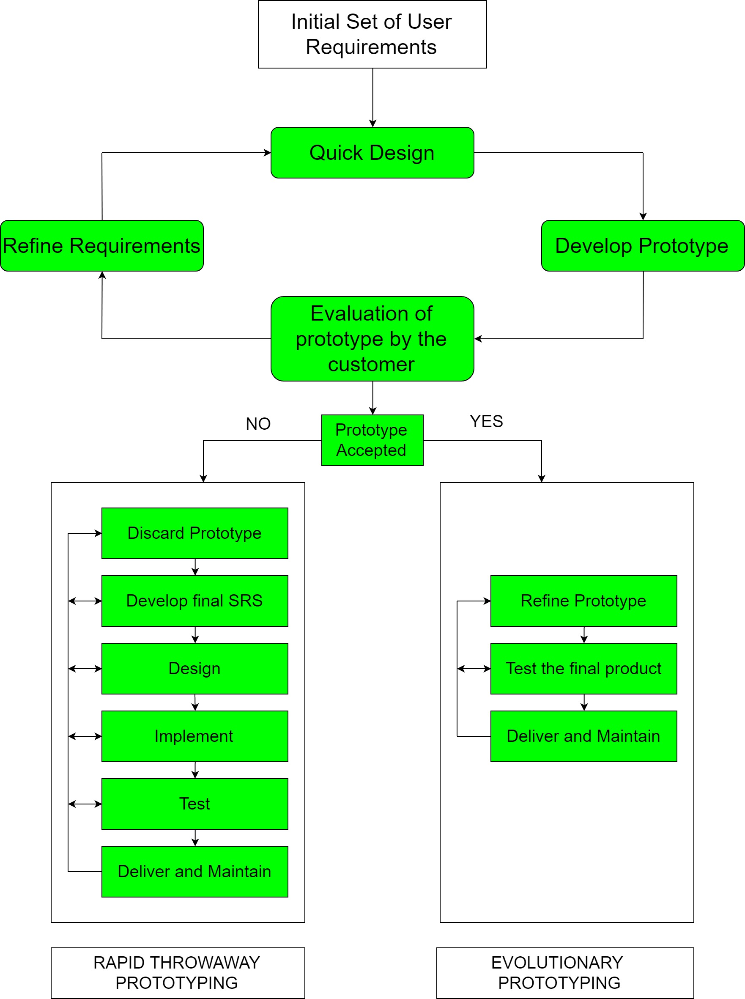
Technology used:
Front end –
1. HTML
HTML stands for Hypertext Markup Language, and it is the most widely used language to write Web Pages.
- Hypertext refers to the way in which Web pages (HTML documents) are linked together. Thus, the link available on a webpage is called Hypertext.
- As its name suggests, HTML is a Markup Language which means you use HTML to simply "mark-up" a text document with tags that tell a Web browser how to structure it to display.
Originally, HTML was developed with the intent of defining the structure of documents like headings, paragraphs, lists, and so forth to facilitate the sharing of scientific information between researchers.
Now, HTML is being widely used to format web pages with the help of different tags available in HTML language.

2. CSS
Cascading Style Sheets, fondly referred to as CSS, is a simple design language intended to simplify the process of making web pages presentable.
CSS handles the look and feel part of a web page. Using CSS, you can control the color of the text, the style of fonts, the spacing between paragraphs, how columns are sized and laid out, what background images or colors are used, layout designs, variations in display for different devices and screen sizes as well as a variety of other effects.
CSS is easy to learn and understand but it provides powerful control over the presentation of an HTML document. Most commonly, CSS is combined with the markup languages HTML or XHTML.
3.PHP
PHP is a general-purpose scripting language that is especially suited to server-side web development, in which case PHP generally runs on a web server. Any PHP code in a requested file is executed by the PHP runtime, usually to create dynamic web page content or dynamic images used on websites or elsewhere. It can also be used for command-line scripting and client-side graphical user interface (GUI) applications. PHP can be deployed on most web servers, many operating systems and platforms, and can be used with many relational database management systems (RDBMS). Most web hosting providers support PHP for use by their clients. It is available free of charge, and the PHP Group provides the complete source code for users to build, customize and extend for their own use.

Back end
MySQL is a fast, easy-to-use RDBMS being used for many small and big businesses. MySQL is developed, marketed and supported by MySQL AB, which is a Swedish company. MySQL is becoming so popular because of many good reasons −
- MySQL is released under an open-source license. So, you have nothing to pay to use it.
- MySQL is a very powerful program in its own right. It handles a large subset of the functionality of the most expensive and powerful database packages.
- MySQL uses a standard form of the well-known SQL data language.
- MySQL works on many operating systems and with many languages including PHP, PERL, C, C++, JAVA, etc.
- MySQL works very quickly and works well even with large data sets.
- MySQL is very friendly to PHP, the most appreciated language for web development.
- MySQL supports large databases, up to 50 million rows or more in a table. The default file size limit for a table is 4GB, but you can increase this (if your operating system can handle it) to a theoretical limit of 8 million terabytes (TB).
- MySQL is customizable. The open-source GPL license allows programmers to modify the MySQL software to fit their own specific environments.

Entity Relationship design:

